To Check Subscription Key Vault Access:

Go to Home > Subscriptions:

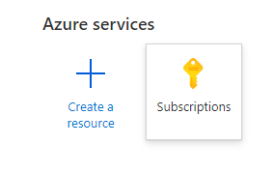

Click within the search text box and start typing either the name or a key part of the name (Such as BPC in this case). The subscriptions will automatically start the search as you type.

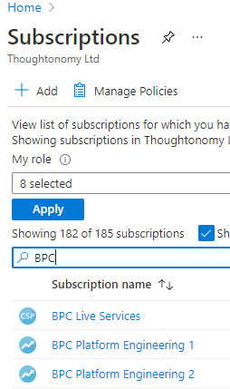

Click on the subscription that you want to get access.



Now click on “Resources” > Then click on the “Type” column name to sort the resources.

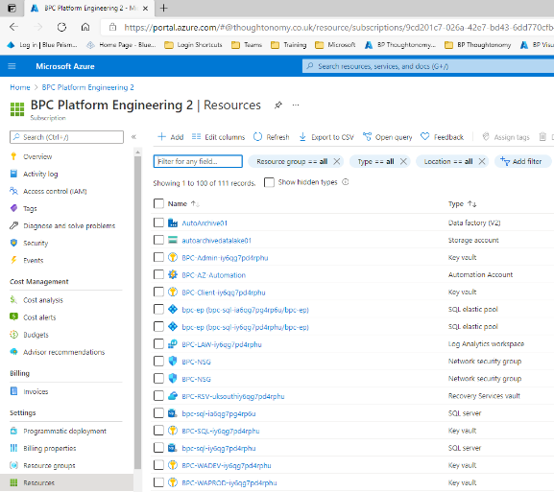

Right click on the key vault and open it in another tab.

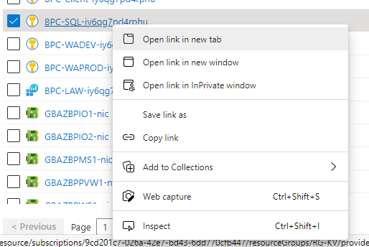

Select the new tab than select Access policies.

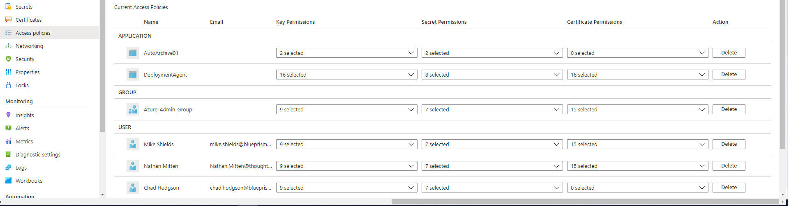

If you do not see your name under user, you will need to request Contributor access in order to be able to access the user account, password and any keys required to access the subscription.